**Metropolitan State University**

**ICS 311 —Database Management Systems**

**Homework #6 Answers**

Due: see syllabus

**Homework #6 Total: 24 Points**

**Question 1: Triggers and Stored Procedures:**

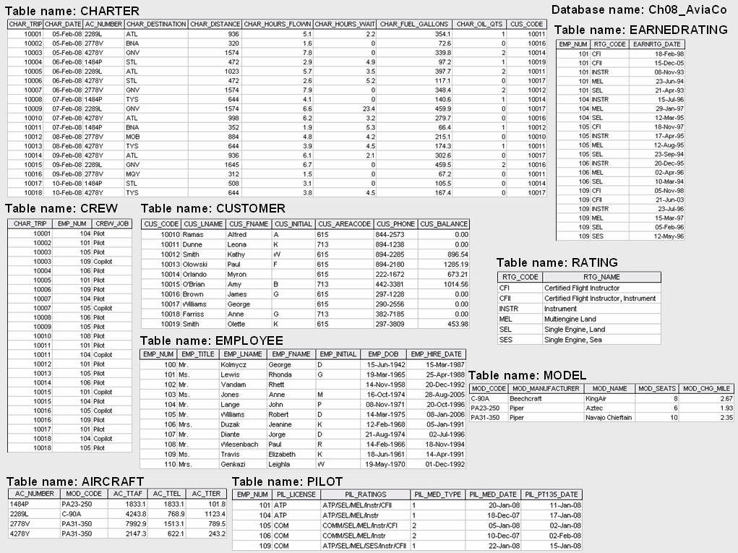

CHAR-TOT-CHG

Download the file named “assignment6_database.sql” from D2L. Run the file from MySQL workbench, putty or Terminal.

After the file completes, the tables shown above are created and populated with the shown data. Familiarize yourself with the database before starting to write your queries. Once you are familiar with the data, start working on the following questions.

What to submit:

1. *A .sql file with all your answers. Make sure that all of your SQL works without error. If there is a failure in your answers (E.g. missing semi colon), grades will be detected.*
2. *This word document with screenshots of your answers, after you have run them. E.g. For view, should the output of the view by using a ‘Select * from’ command. For a trigger, show before and after results of the table on which trigger was created. For procedure, use the ‘Call’ command to get the results*

**Answer the following questions based on the above database:**

1. (4 Points) Create a view named “ATL_CHARTERS_V” that includes the following “For each charter of aircraft to Atlanta (STL), print the charter date, charter hours flown, and the corresponding customer last name, first name, area code, and phone number”. Your answer should include both the SQL statement for view creating along with the contents of the view (you get the contents of the view by select * from ATL-CHARTERS_V).

CREATE VIEW ATL_CHARTERS_V AS

(SELECT ch.char_date, ch.char_hours_flown, c.cus_lname, c.cus_fname, c.cus_areacode, c.cus_phone

FROM Charter ch, AC_Customer c

WHERE ch.cus_code = c.cus_code

AND char_destination = 'ATL');

1. (4 Points) Modify the MODEL table to add the following attribute and insert the values shown in the following table. (Note: use ALTER TABLE and UPDATE commands.)

|  |  |  |  |
| --- | --- | --- | --- |
| **Attribute name** | **Attribute Description** | **Attribute type** | **Attribute Values** |
| **MOD_LIFT_ WEIGHT** | **Amount of weight each model can lift:** | **Numeric** | **10,000 for DC-90A**  **5,000 for MA23-250**  **20,000 for PA31-950** |

ALTER TABLE Model

ADD COLUMN MOD_LIFT_WEIGHT int;

UPDATE Model

SET mod_lift_weight = 10000

WHERE mod_code = 'DC-90A';

UPDATE Model

SET mod_lift_weight = 5000

WHERE mod_code = 'MA23-250';

UPDATE Model

SET mod_lift_weight = 20000

WHERE mod_code = 'PA31-950';

1. (4 Points) Create a trigger named trg_charter_hours that will automatically update the AIRCRAFT table after a new CHARTER row is added. Use the CHARTER table’s CHAR_HOURS_FLOWN to update the AIRCRAFT table’s AC_TTAF, AC_TTEL, and AC_TTER values.

The meaning for the AIRCRAFT table columns are as follows:

**AC_TTAF:** Total time on the air frame

**AC_TTEL:** Total time on the left engine (Also used to record single engine hours) **AC_TTER:** Total time on the right engine.

So in the trigger, you need to increase all of them with CHAR_HOURS_FLOWN

delimiter //

CREATE TRIGGER trg_char_hours

AFTER INSERT ON Charter

FOR EACH ROW

BEGIN

UPDATE Aircraft

SET ac_ttaf = ac_ttaf + new.char_hours_flown,

ac_ttel = ac_ttel + new.char_hours_flown,

ac_tter = ac_tter + new.char_hours_flown

WHERE Aircraft.ac_number = new.ac_number;

END;

// delimiter;

1. (4 Points) Create a trigger named trg_cust_balance that will automatically update the AC_CUSTOMER table’s CUS_BALANCE before a new CHARTER row is added. Use the CHARTER table’s CHAR_TOT_CHG as the update source (Assume that all charter charges are charged to the customer balance.) In addition to the CHAR_TOT_CHG, add $25 for every quart of oil used on the charter.

delimiter //

CREATE TRIGGER trg_cust_balance

BEFORE INSERT ON Charter

FOR EACH ROW

BEGIN

UPDATE AC_Customer

SET cus_balance = cus_balance + new.char_tot_chg + (25 * new.char_oil_qts)

WHERE AC_Customer.cus_code = new.cus_code;

END;

// delimiter;

1. (4 Points) Create a stored procedure to update model charge per mile attribute. Procedure takes the model number as a parameter. The procedure increases the charge for this model by 25%.

delimiter //

CREATE PROCEDURE prc_mod_charge_increase (IN W_MOD_CD varchar(10))

BEGIN

UPDATE Model

SET mod_chg_mile = mod_chg_mile * 1.25

WHERE mod_code = W_MOD_CD;

END;

// delimiter;

1. (4 Points) Create a stored procedure that will take an Employee number and percentage, then update the corresponding employee’s hourly salary by the input percentage (increase the hourly salary, so you are giving the employee a raise).

**Hint**: A*lter Employee table to add the hourly_salary field, update it with a value of 30 for all rows in the table, before creating the procedure.*

alter table employee

add hourly_salary double;

update employee

set hourly_salary = 30;

commit;

delimiter //

create procedure prc_increase_salary(in W_EMPLOYEE int(11), in W_PERCENT_INCREASE double)

begin

update employee

set hourly_salary = hourly_salary * (1 + W_PERCENT_INCREASE / 100)

where emp_num = W_EMPLOYEE;

end//

delimiter ;